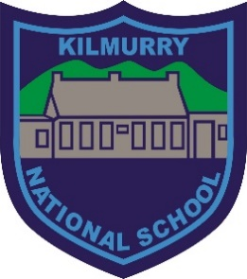
Kilmurry National School
S.N. Cill Mhuire

Policy on the use of the Our School’s Social Media Pages

Rationale:
Maintaining an online presence is vital for schools, not only in terms of keeping the school community up to date with what’s happening in the school, but also in terms of attracting potential enrolment. Having a school website is an essential part of this, but web users must specifically visit the school website regularly to receive the information. By having Facebook, Twitter or other social media pages the school is feeding school information, news and notices directly into the personal news feeds of parents and the wider school community.
Aims: The purpose of having a school Facebook page, Twitter page or other social media pages is:
- To continue to advance our school communication system with information shared via Facebook and/or Twitter, along with the existing methods of text messages, email, Aladdin Connect and the school website.
- To publicise school events and increase awareness about school fundraising.
- To announce any updated information that appears on our website via Facebook, Twitter and/or other social media pages.
- To highlight positive school achievements in a forum where they can be shared by the school community.
- To make school announcements (e.g. school closures)
- To use Facebook, Twitter and/or other social media as means of marketing the school to a wider audience.
- To have Facebook, Twitter and/or other social media feeds embedded on the homepage of the school website.
- To engage the community that Kilmurry National School serves and act as a key component of our school’s online presence.
- To facilitate communication and networking opportunities between parents especially new or prospective parents.
- To maintain contact with past parents and past pupils.

Terms of Use of Kilmurry National School’s Facebook, Twitter other social media pages:
- Users cannot advertise products or services on our school Facebook, Twitter and other social media pages.
- Users should not post anything on the pages that could be deemed as offensive – inappropriate or harmful comments/content will be removed immediately.
- Users should not engage in giving negative feedback on Facebook, Twitter or other social media pages - it is more appropriate to deal with the school directly on such matters.
- Users will not mention individual staff members in a negative light on the school’s Facebook, Twitter or other social media pages.
- Users should not ask to become “friends” with staff as failure to respond may cause offence.
- Users cannot tag or post photographs of children on the pages.
- Users should not add comments that can identify children.

The sanction for any user breaking any of the above rules is an automatic ban.

Points to Note
- Facebook and Twitter both list a minimum age requirement of 13, therefore all parents are reminded that children under the age of 13 should not be on Facebook or Twitter.

Ratified by Board of Management on: 14/09/2020
Signed: Kathleen Creedon (Principal)
Signed: Nora Murphy (Chairperson B.O.M)

